**Learning Disability Partnership Workshop, 3rd December 2024**

1. **Introduction**

The Redbridge Learning Disability Partnership has been running for over 20 years. It is recognised that the partnership needs to change to reflect the developments in learning disability services in that time.

Therefore, the partnership agreed to use it’s December 2024 meeting as a workshop to scope out what the changes would look like and set the direction for the partnership for the coming years. All of the contributions from the Workshop were typed up in Appendix 1.

This document summarises the discussion and suggests action which need to be taken forward to develop the Learning Disability Partnership.

1. **Background**

Set up in 2001 the Learning Disability Partnership has been a fixture for the Learning Disability community in Redbridge. Recently, the agendas have become less relevant and it has lost some of the impact it once had.

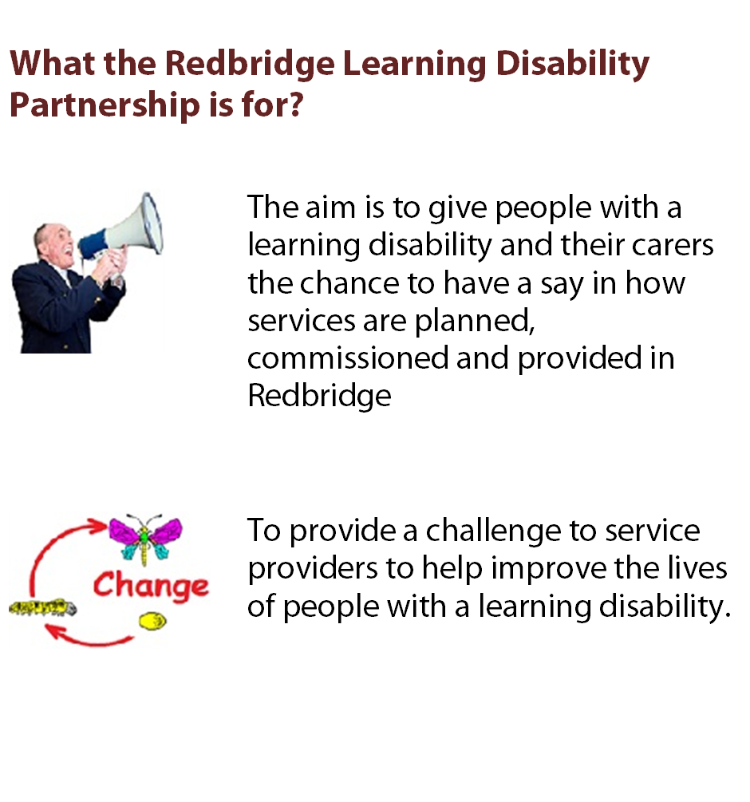

The workshop was well attended by a range of organisations including service user representatives, carers, the Council, NELFT, voluntary organisations and service providers.

1. **The questions we aimed to answer**

The workshop was organised around six key questions:

* Where do we want the Partnership Board to be in 12 months?
* How well do you think we are doing against us objectives?
* What would you like to change about the Board?
* Which organisations need to be at the board and why?
* What are we agreeing to?
* What do we need to do next?

1. **Key messages coming from the discussion**

The Partnership should continue

People thought the LDP should continue as a place where the voice of the learning disability community could be heard. There was a strong message about the Partnership continuing and for it to remain independent.

After many years of dedicated service, Alan Norris recently retired as Chair of the LDP due to ill health. As a temporary measure, Sue Tatch, Redbridge Assistant Director for Mental Health & Learning Disabilities and Head of Service Fairlop HASS has offered to chair the Board with the aim of appointing a new chair from the learning disability community.

***Action 1: Appoint a new chair for the Board.***

Direction for the Partnership

The Board needs to have a clear purpose with objectives and an agenda with goals and that people identify with.

As well as health and social care, people with learning disabilities face barriers in education employment and independent living. The need for a wider Redbridge Learning Disability Strategy came over as a key issue and it should be a role for the Board to guide it.

Might be good to have some workshops setting our own priorities or adopting these ones? There is more detail on the site if you haven’t looked at it.

Autism also needs to be included in its scope. However, it is important to recognise the difference between learning disability and autism and how we might take it forward.

Some people with Autism are very able and people with LD may be overshadowed. This should be taken into consideration.

***Action 2: For the LDP to lead in developing a Learning Disability and Autism Strategy for Redbridge.***

Raising the Influence, Visibility and Profile of the Partnership

People wanted the Partnership to have some “real power” to scrutinise and input to plans and budgets rather than a tokenistic approach.

To get to a position of influence there was an acceptance that the Board needs to be more organised, structured and diverse with representation from providers, service users, family and carers, local authority commissioners etc.

There was a clear message about getting better responses from the Council and other stakeholders to recommendations made by the Board. This would require continued senior local authority and NHS reps.

There needs to be greater visibility and profile of the Partnership across a broad range of stakeholders including staff, service users and carers.

It is important that the Board makes a difference and reports back to stakeholders effectively.

The Learning Disability England National Framework Good Lives was cited as a template from which to work.

***Action 3: Use the*** [***Good Lives Framework***](https://www.learningdisabilityengland.org.uk/what-members-are-saying-and-doing/good-lives-building-change-together/) ***as a benchmark to measure how well partners are doing in meeting the needs of people with learning disabilities.***

More user involvement and bringing in New People

Many people made the point about having more service user involvement and to give more people with learning disabilities from different groups a chance to get involved.

Service users and carers reps should have more input on the agenda setting so that issues of concern to service users are given priority at Board meetings.

Their role should be to Advocate for better care provision, continue to speak up and make a difference.

There was strong support for expanding the representation of carers and engage with more younger carers representatives, parent carer of adults with a disability and parent carer fora.

There was a call for more Support for Older Carers through specific projects and acknowledgement.

The views of non-verbal people need to be taken into account.

***Action 4: Review the membership and structure of the partnership to be more representative of the learning disability community and have more of an impact on service development.***

1. **Which organisations need to be at the board and why?**

A board range of stakeholders was suggested:

* ELHAP, Social Work Team, Healthwatch, EPT, OPE Planning Group.
* Education, Schools, Community Safety and Sheltered Housing
* Service user reps from Day Services. WEL enterprise rep from Link Place, Woodbine and Elderberries.
* Health - NELFT ICB and GPs – commissioning, service user involvement organisations have to get feedback from Service Users ongoing.
* Service Provider Reps.
* Redbridge Forum
* One Place East

Some specific points were made on the role of Providers on the Board.

* The Board should play a more challenging role with providers
* More effective provider representation to cover providers issues and their concerns.

**Action 5: Review the membership and structure of the Partnership to more effectively represent and influence learning development service provision.**

1. **Meeting arrangements**

Better planning ways of having a discussion, not just a group around a table with a fixed agenda. Avoid Jargon, manage the time to avoid people feeling rushed or missing their chance to speak. information sharing comes under any other business

The Board should oversee the delivery of the Learning Disability strategy through establishing a core group and co-opt relevant experienced people for specific meetings on key topics. They should undertake work outside of the Board and report back. This would need funding and support.

Build the representative role so that there are not too many people around the table and represent wider interests.

**Action 6: Review the Partnership arrangements to more effectively structure and organise the business.**

In recent years, since the Partnership went back to in person to person meetings following the pandemic, the partnership meetings have been held at different venues across the Borough including:

• Woodbine Club House.

• Tesco Goodmayes

• Elderberries

• Ilford Islamic Centre

• Lynton House

There was a strong view expressed that the meetings should meet at a fixed venue.

**Action 7: Find a new permanent home for the Partnership.**

Make sure that all main points are pointed out and acted upon.

Budget decisions need to be presented to the Board in time for it to influence them.

Ensure the reps feel valued. Support Service user reps to engage through training on engagement and inclusion. Important that service users and carers receive refresher training on being a rep.

Funding or support is needed to run task groups and other workshops or regular meetings. Including a review of the current remuneration model.

Service user pre meets are going well. However, it would be good to see something similar for the Carers and possibly providers, so that the Board can prepare to discuss the issues raised and the Chair can better time manage the contributions.

The conduct of the meetings should ensure that:

* Information is in Easy Read format
* Presentations need to be relevant to the work of the Board.
* When people speak, don’t use jargon.

**Action 8: Draft Terms of Reference to the next Board in March 2025.**

1. **Summary of actions coming out of the LDP Workshop 3rd December 2025**

|  |  |  |  |
| --- | --- | --- | --- |
| **Actions** | **Description** | **Lead** | **By When** |
| **Action 1** | **Appoint a new chair for the Board.** |  |  |
| **Action 2** | **For the LDP to lead in developing a Learning Disability and Autism Strategy for Redbridge.** |  |  |
| **Action 3** | **Use the Good Lives Framework as a benchmark to measure how well partners are doing in meeting the needs of people with learning disabilities.** |  |  |
| **Action 4** | **Review the membership and structure of the partnership to be more representative of the learning disability community and have more of an impact on service development.** |  |  |
| **Action 5** | **Review the membership and structure of the Partnership to more effectively represent and influence learning development service provision.** |  |  |
| **Action 6** | **Review the Partnership arrangements to more effectively structure and organise the business.** |  |  |
| **Action 7** | **Find a new permanent home for the Partnership.** |  |  |
| **Action 8** | **Draft a new Terms of Reference to the next Board in March 2025.** |  |  |

**Appendix 1: Transcript of the ideas and suggestions put on Post It Notes at the 3rd December Workshop**

**Where do we want the Partnership Board to be in 12 months?**

**Venue**

Hold meetings in a more accessible place.

Venue easy to get to

Meetings should move around the Borough

A fixed building

**Continuing**

Still going strong

Redbridge Forum to continue.

For partnership board to still be around.

Still in existence

Remain independent as LDP Board.

**More user involvement**

More user involvement

**New People**

Different Groups included.

Give more people with LD a chance to get involved.

**Training**

Training for partnership reps.

A new chair for the board

Look into the lack of support for adults with LD.

**Support for Older Carers**

More support and acknowledgement of older carers

Social workers – at the moment it is difficult to get hold of SW/quick turnover.

More support for older carers (specific projects)

**Users carers involvement.**

Users carers involvement.

More service user involvement.

**Influence**

Better responses from the LA to recommendations.

More council attendance and providers (but not at the detriment of service users /carers.

Real power: plans and budgets. Not tokenistic.

To be in a position of influence and strength with a diverse board of service providers, service users, family and carers, local authority commissioners etc.

Continued high level local authority and NHS reps.

**Visibility and Profile**

More visible to all organisations: staff, users of service and carers.

Much higher profile i.e. how many people know about it?

Greater visibility across a broad range of stakeholders.

Report on the difference the Board makes.

**Voice of carers**

Meetings need to be kept on track as items at the end f the agenda often have no time left.

Continue to speak up and make a difference

Could the Good Lives Framework be used to evaluate various groups.

Presentations to be relevant to the work of the Board.

Easy read information

When you speak don’t use jargon.

More resources available to find out people’s preferences.

**Service user involvement**

Issues of concern to service users should be given priority at Board meetings.

Service users and carers rep should have more input on the agenda setting.

LD individuals face barriers in education employment and independent living.

Advocate better care provision.

**Carers**

Carers issue are more important than future plans in XXX with Redbridge.

More (younger) carer reps.

Carers of LD. How are they supported.

**Providers**

Providers issues regarding their concerns about provider XXXX.

More provider reps.

Is there a standard of training for care providers?

**Parent carers**

More parent carers of adults with a learning disability.

More members of parent carer forums to participate.

**How well do you think we are doing against us objectives?**

* **What does it do well?**

**Participation and Voice**

Participation x 2nd

Speaking up x 2

**Information sharing**

Information sharing

Do well with updates and hearing what going on.

**Direction**

Clear direction needed Social Care, Health, Respite, Day Services, Home care

We need a Redbridge Learning Disability Strategy

Do we have Learning Disability Strategy? Can we us this to guide the Board?

Action Plan

**What could the LDP it do better?**

Not challenging providers

**Visibility and Profile**

Not know about

More training for the Board needed.

Difficult to get responses from authorities. Maybe not valued enough.

Action in response to voice.

More service users carers.

Lets talk about money! Presentation of Budget

Who attends/invited.

**Information Sharing**

Good suggestions. How they are shared with others.

**Providers**

Is there standard of training for care providers.

Those that can impact funding need to understand the needs.

Can not rely on funding continuing.

What are other boroughs doing?

**What is the Redbridge Learning Disability Partnership for?**

???

**What would you like to change about the Board?**

**Direction**

Workshops – National Framework Good Lives as a template from Learning Disability England.

Not Just information sharing.

Not just a talking shop.

**Influence**

Right level of seniority

Autism?

**Meeting arrangements**

Offer Lunch

Support service users

**Which organisations need to be at the board and why?**

**Stakeholders**

ELHAP, Healthwatch, EPT, OPE Planning Group.

Social Work Team

Education, Safety and Sheltered Housing

Service user reps from Day Services.

GPs – commissioning, service user involvement orgs have to get feedback from Service Users ongoing.

WEL Enterprise, rep from Link Place and Elderberries.

NELFT ICB

Service provider Reps.

Woodbine, Redbridge Forum, Schools?

WEL enterprise rep form Link Place and rep form Elderberries.